**Parser Report**

* **Group member : 钟艾彤 (5230000530)**
* **Test :**

**Implemented grammars:**

《program》

<program> => (<stmt>)+

《expression》

<expr> =>  <non-op-expr>  | <binop-expr> | <unop-expr>

<non-op-expr> => <id> | <literal> | <fun-call> | <paren-expr> | <if-expr> | <block> | <construct-expr> | <lambda-expr>

<unop-expr> => <unop> ( <non-op-expr> |  <paren-expr> )

<unop> => not

<binop-expr> => <non-op-expr> <binop> ( <non-op-expr> | <paren-expr> )

<binop> => [+ , - , * , / , %, < , <= , > , >= ,  ==]

<paren-expr> => \( <expr> \)

<if-expr> =>

   if <expr> : <block> (<else-if>)+  (else: <block>)? end |

   if <expr> : <block> (<else-if>)*  else: <block> end

‹else-if› =>  else if <expr> : <block>

<fun-call> => <id>  \(  (e  | (<expr> ,)* <expr> )  \)

<block> => <stmt> | block :  <stmt>* end

<construct-expr> => <array> | <list>

<list> => \[ list: (e  | (<expr> ,)* <expr> ) \]

<array> => \[ array: (e  | (<expr> ,)* <expr> ) \]

<lambda-expr>  => lam <fun-header> : <block> end

《statement》

<stmt> =>  <when-stmt> | <assign-stmt> | <expr> |

            <decl-stmt> | <binding-stmt>

<stmts> => (<stmt>) *

<assign-stmt> => <id> := <expr>

<when-stmt> => when <expr> : <block> end

<decl-stmt> => <var-decl> | <fun-decl>

<var-decl> => (shadow)? (rec)? var <id> = <expr>

<fun-decl> => (shadow)? (rec)? fun <id> <fun-header> : <stmts> end

<fun-header> => \( < params>  \) (<return-part>)

<return-part> =>  -> <type-name>

<params> => e | <param_list>

<param_list> => (<param> ,)* <param>

<param> =>  (shadow)? <id> [:: <type-name>]

<binding-stmt> => <id> = <expr>

《literal》

<literal> => <boolean> | <string> | <nothing> | <number>

<boolean> =>  true | false

<string> => <single_quote_str> | <double_quote_str> | <multi_line_str>

<single_quote_str> => ' ([ASCII]-[' \n] | \')* '

<double_quote_str> => " ([ASCII]-[" \n] | \")* "

<nothing> => e

<number>  =>  <integer>

<integer> => [- \+]? [0-9]+

《names》

<id> => (<name>) – (<keyword>)

<type-name> => Any | Number | String | Boolean | Nothing | Function

**Test results with simple correct Pyr code:**

**<id> => (<name>) – (<keyword>)**

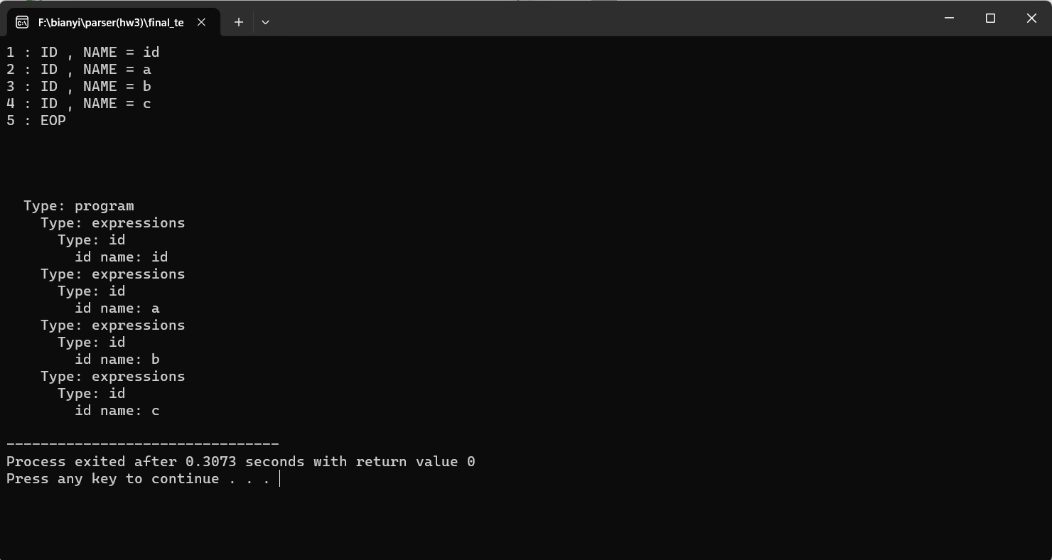

**<literal> => <boolean> | <string> | <nothing> | <number>**

**<boolean> =>  true | false**

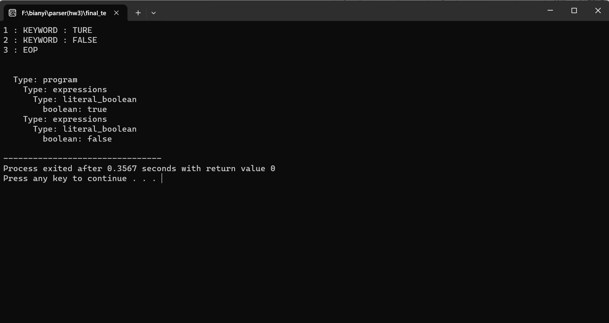

**<string> => <single_quote_str> | <double_quote_str> | <multi_line_str>**

**<single_quote_str> => ' ([ASCII]-[' \n] | \')* '**

**<double_quote_str> => " ([ASCII]-[" \n] | \")* "**

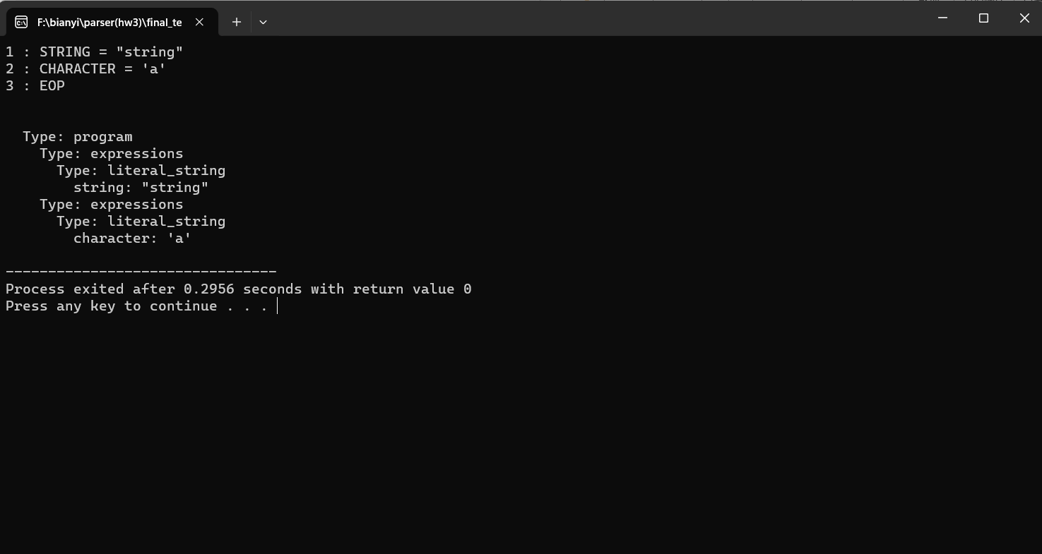

**<nothing> => e**

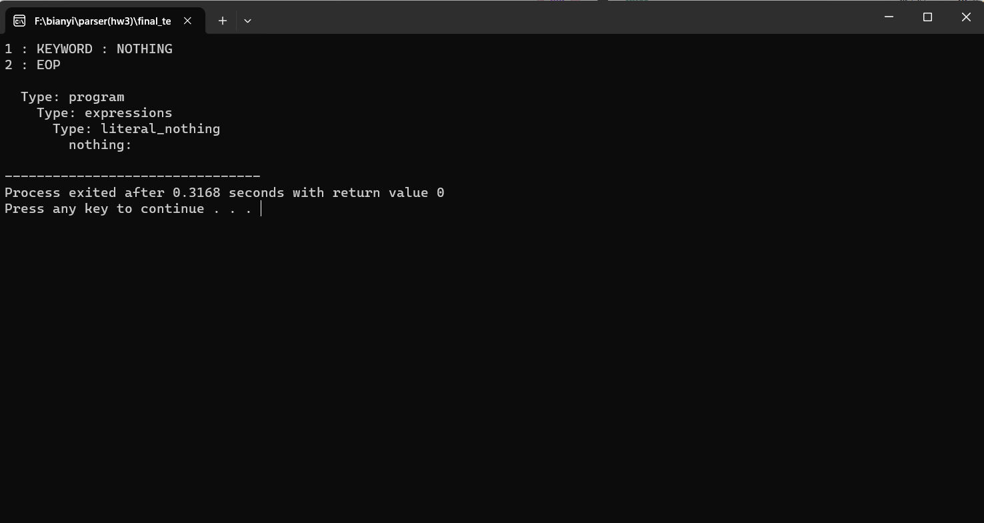

**<number>  =>  <integer>**

**<integer> => [0-9]+**

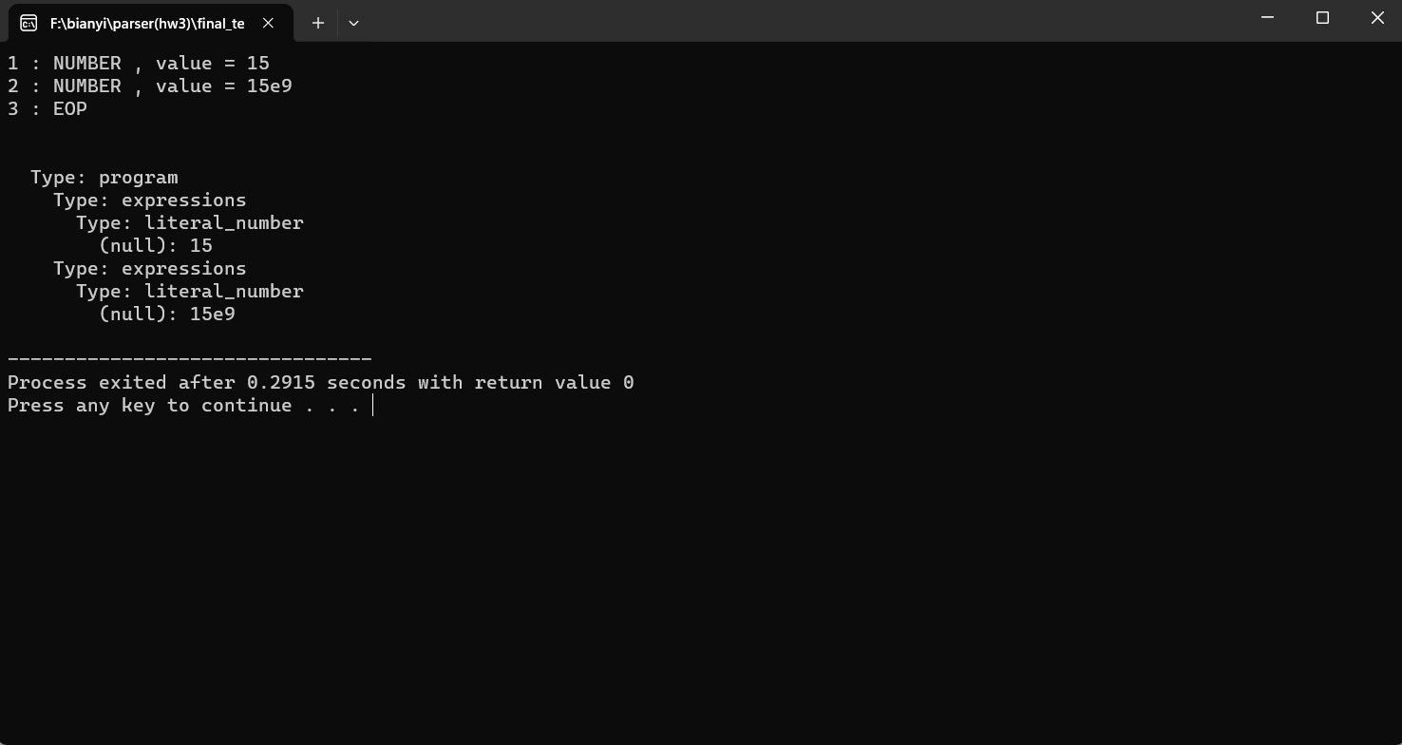

**<fun-call> => <id>  \(  (e  | (<expr> ,)* <expr> )  \)**

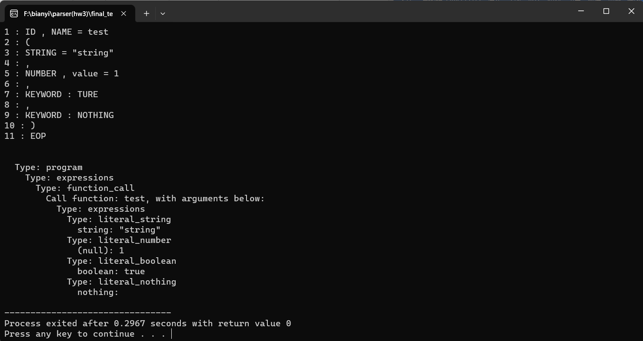

**<paren-expr> => \( <expr> \)**

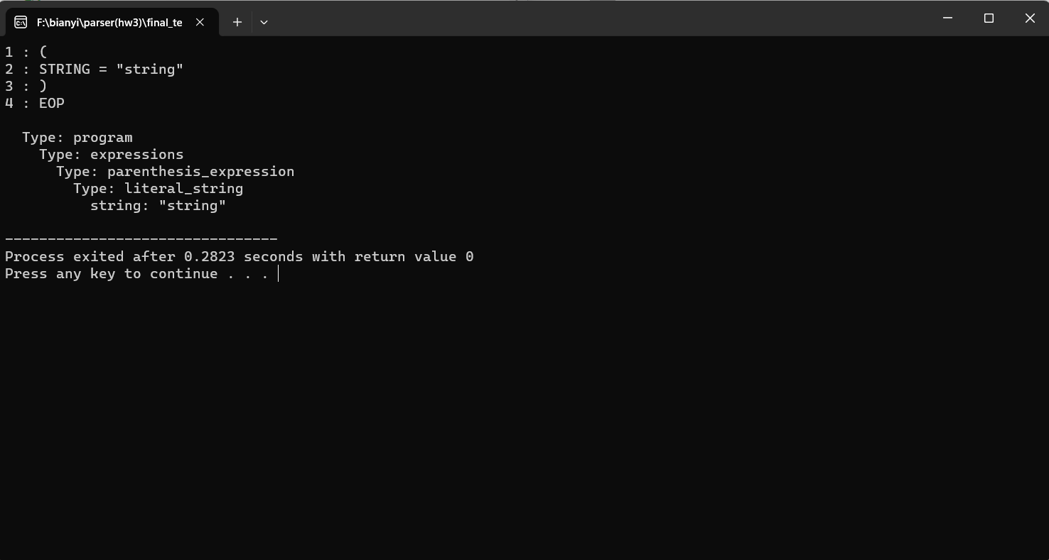

**<construct-expr> => <array> | <list>**

**<list> => \[ list: (e  | (<expr> ,)* <expr> ) \]**

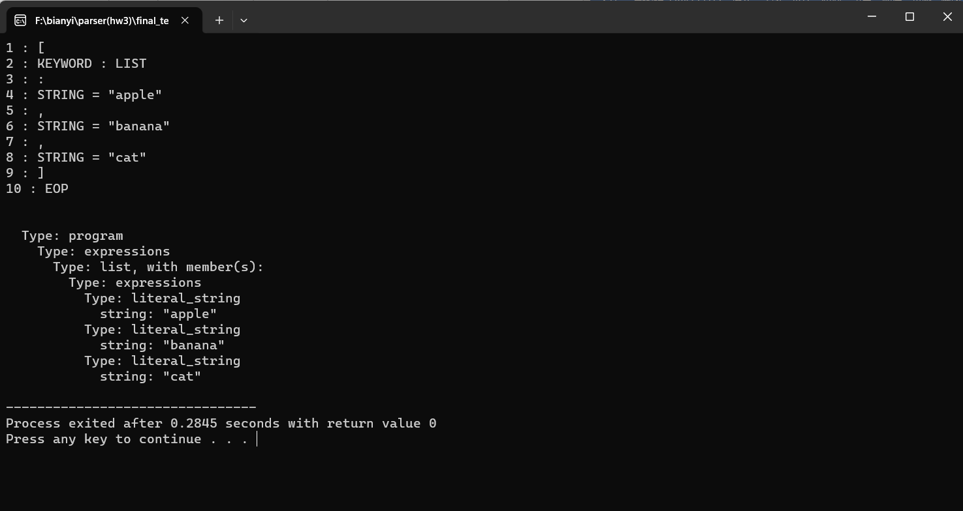

**<array> => \[ array: (e  | (<expr> ,)* <expr> ) \]**

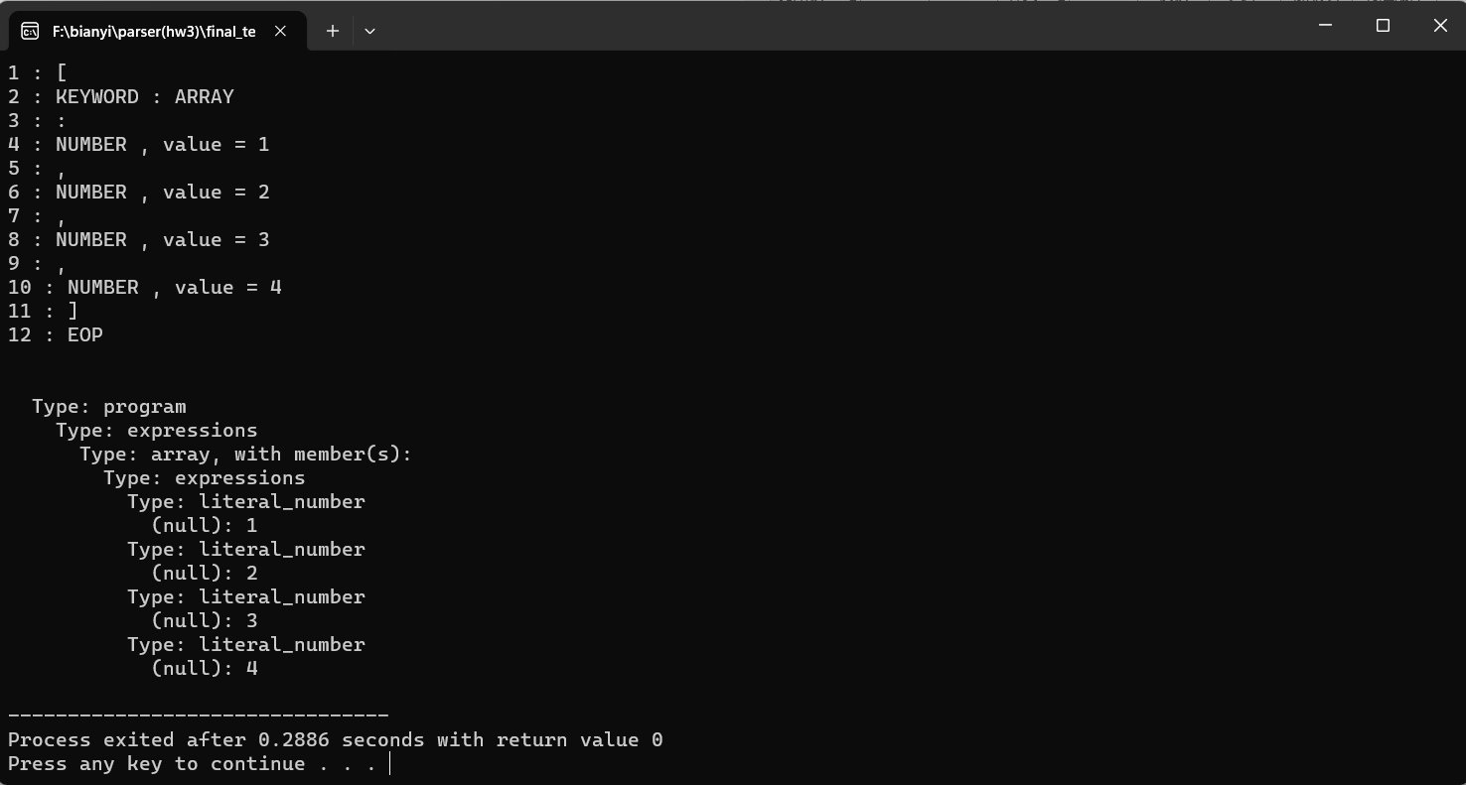

**<unop-expr> => <unop> ( <non-op-expr> |  <paren-expr> )**

**<unop> => not**

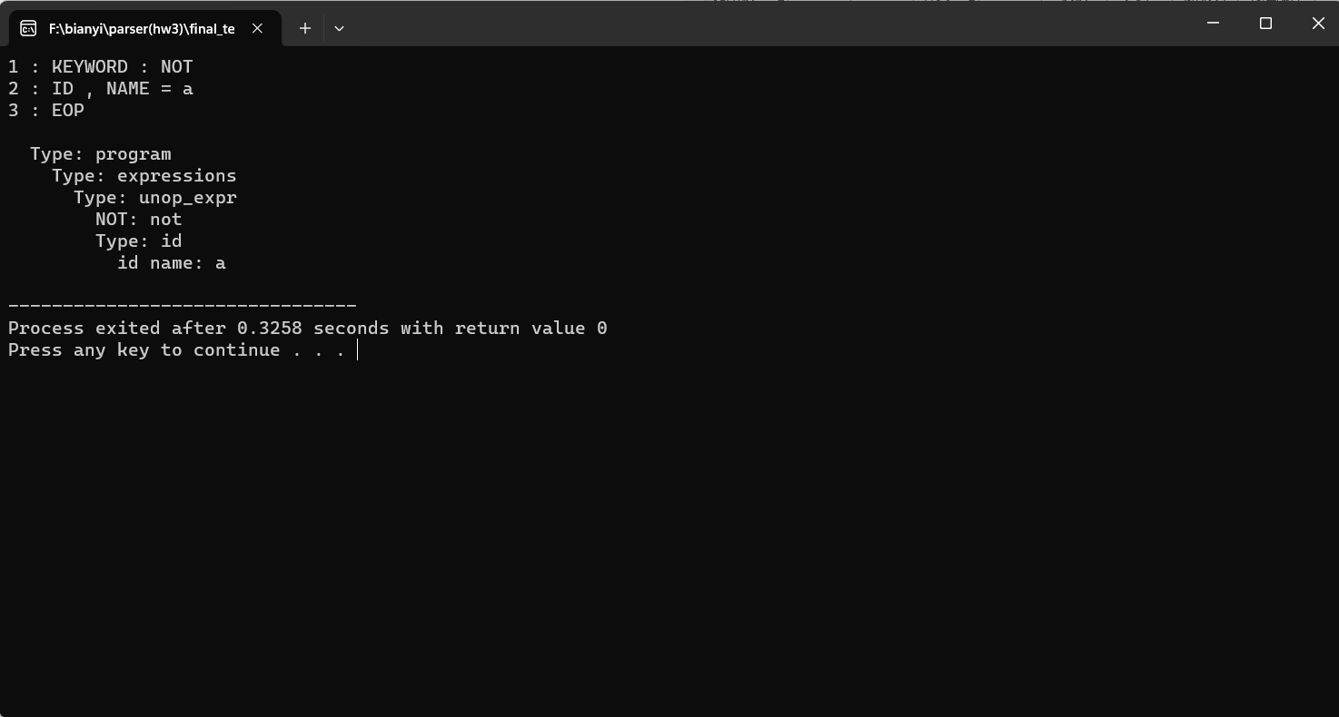

**<binop-expr> => <non-op-expr> <binop> ( <non-op-expr> | <paren-expr> )**

**<binop> => [+ , - , * , / , %, < , <= , > , >= ,  ==]**

**<binding-stmt> => <id> = <expr>**

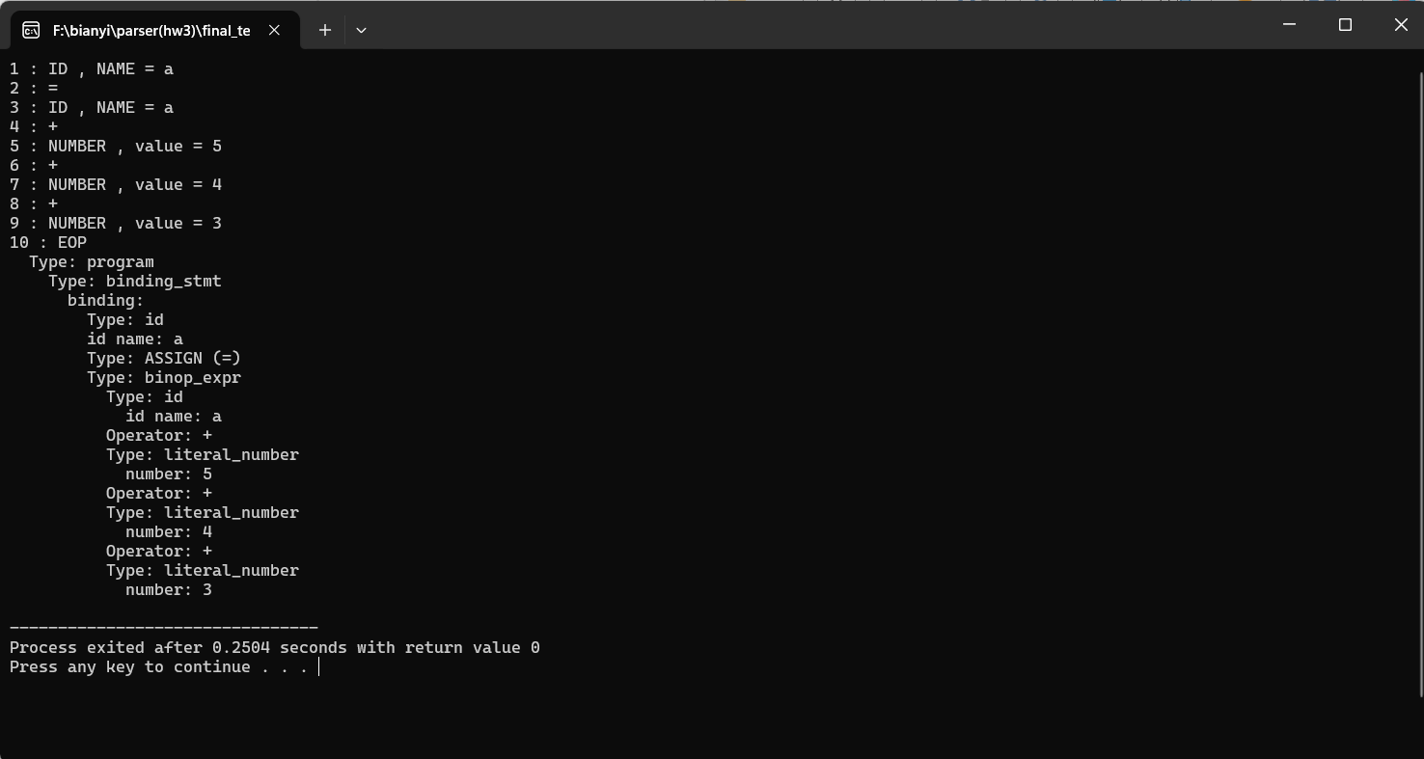

**<if-expr> =>**

**if <expr> : <block> (<else-if>)+  (else: <block>)? end |**

**if <expr> : <block> (<else-if>)*  else: <block> end**

**‹else-if› =>  else if <expr> : <block>**

**[if -else]**

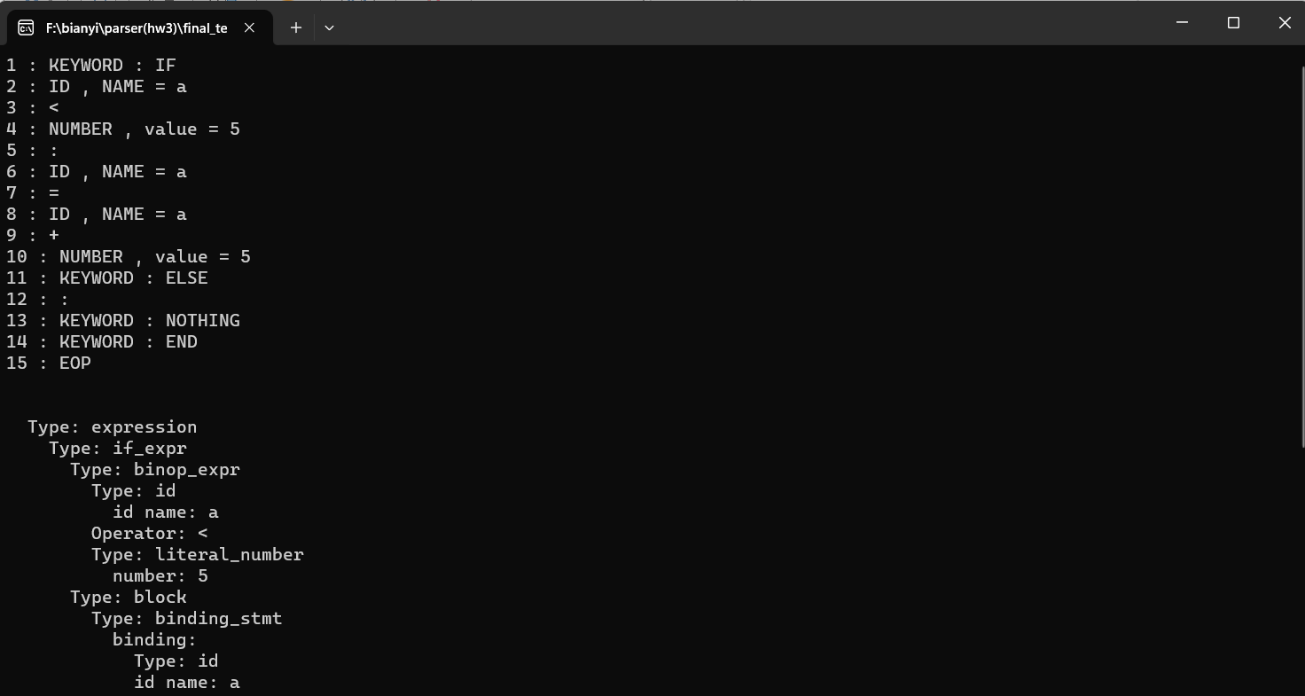

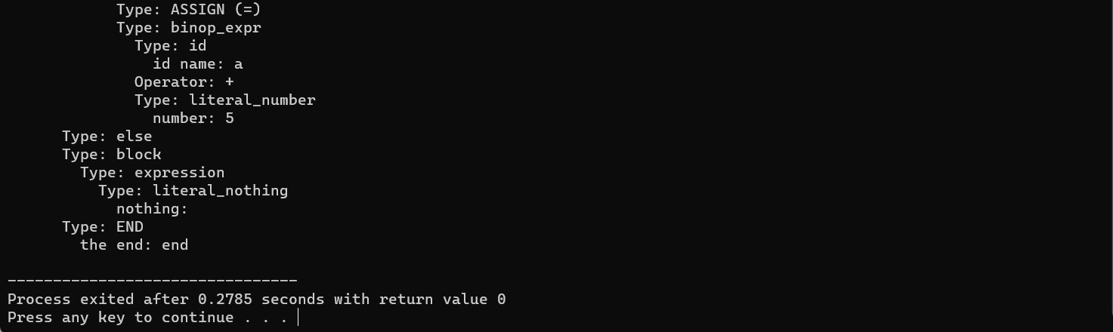

**[if-elseif]**

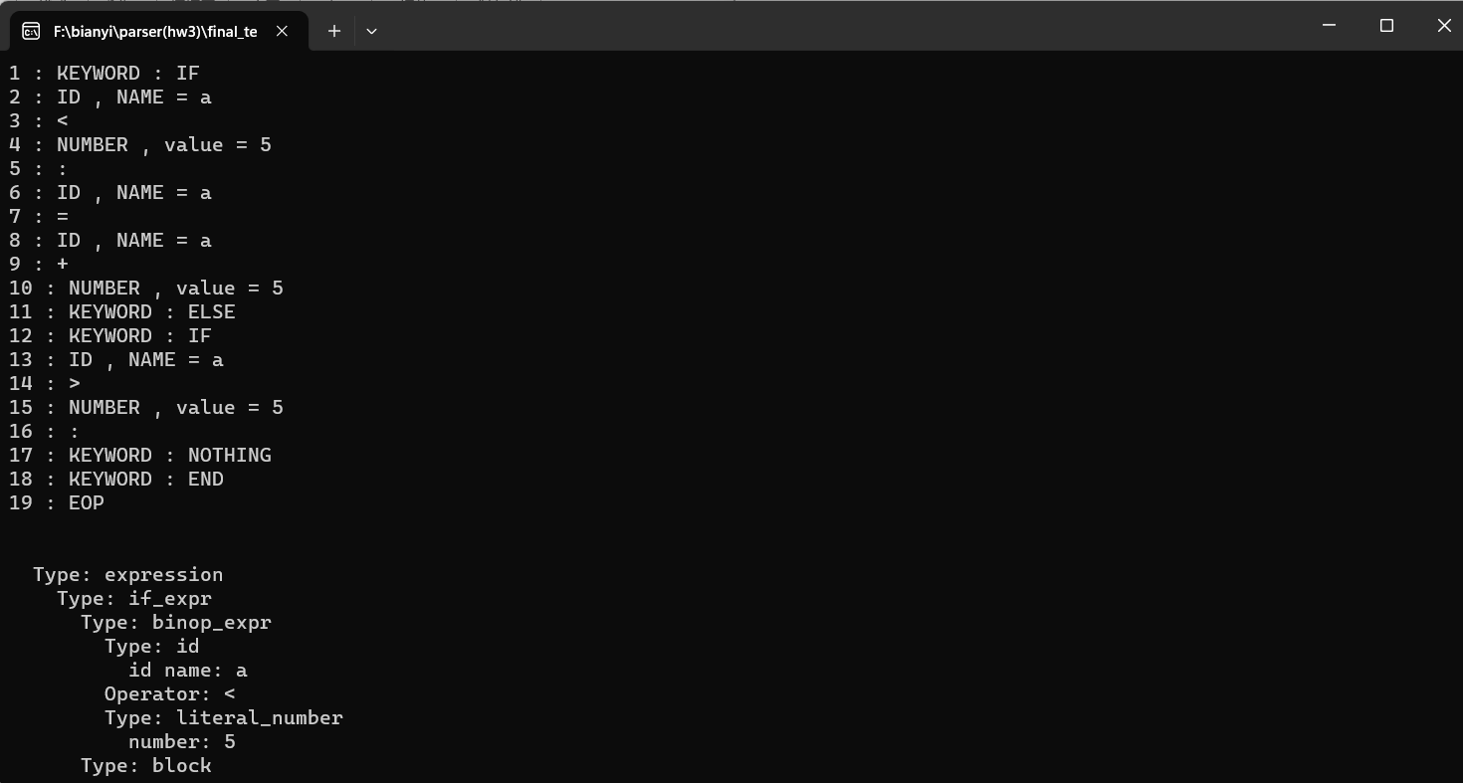

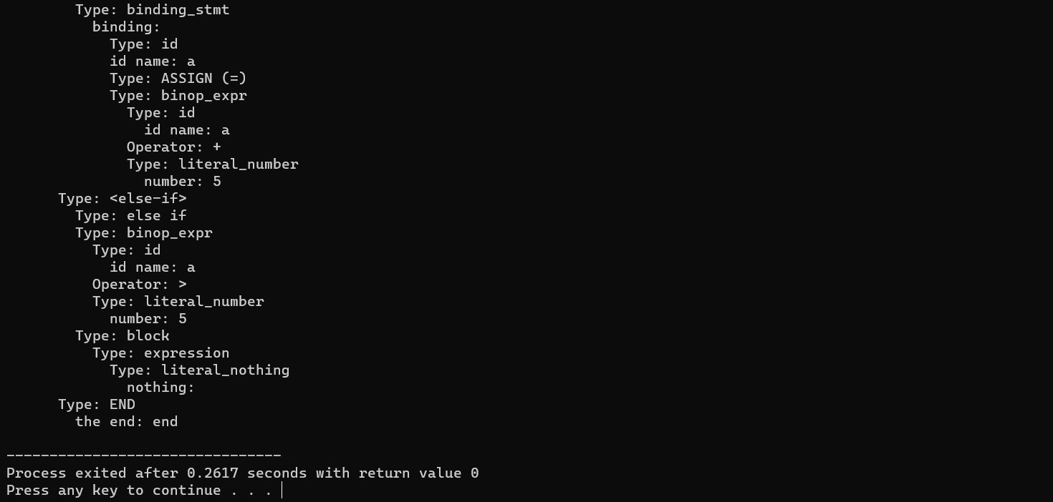

**[if-((elseif)+)-else]**

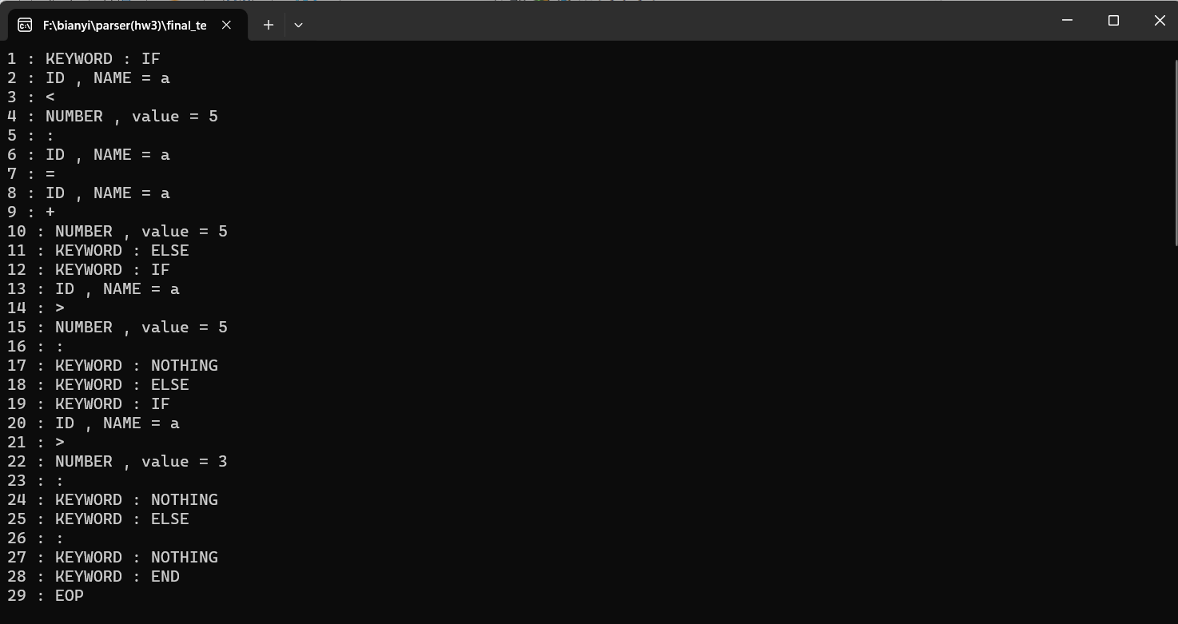

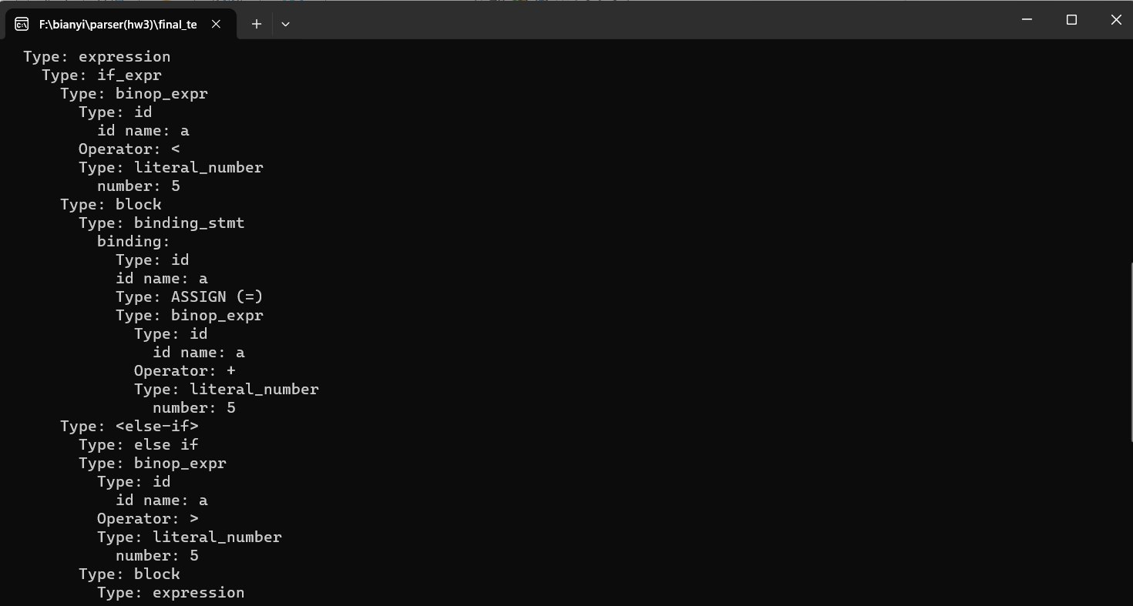

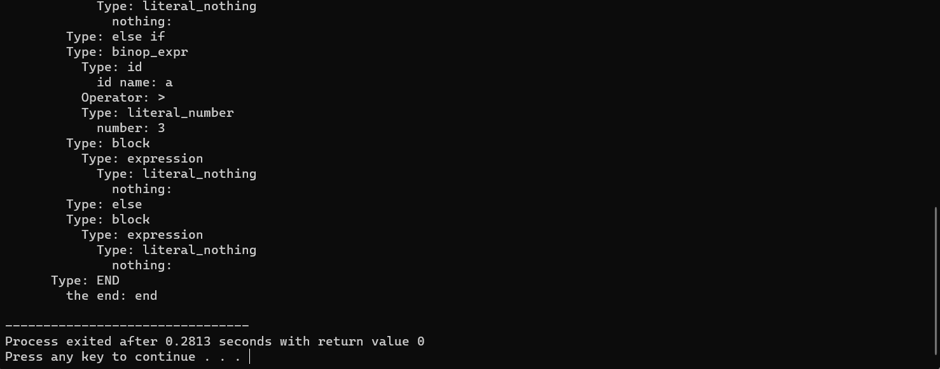

**<lambda-expr>  => lam <fun-header> : <block> end**

**<block> => <stmt> | block :  <stmt>* end**

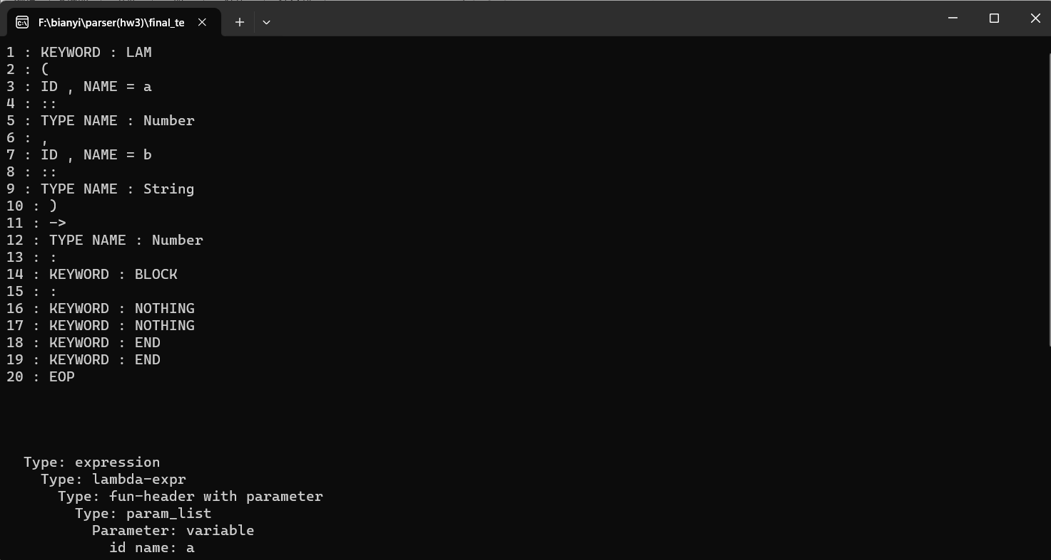

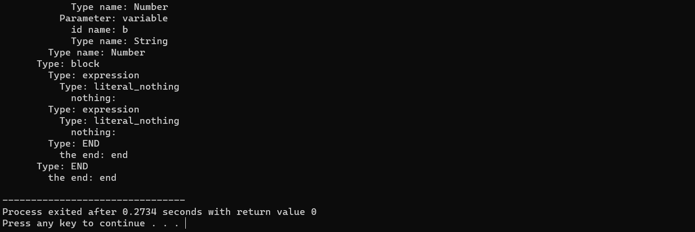

**<stmts> => (<stmt>) \***

**<stmt> =>  <when-stmt> | <assign-stmt> | <expr> |**

**<decl-stmt> | <binding-stmt>**

**<assign-stmt> => <id> := <expr>**

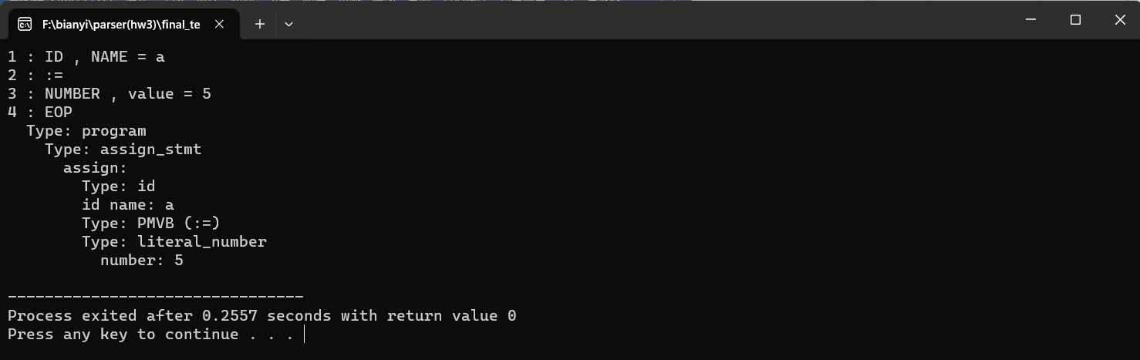

**<when-stmt> => when <expr> : <block> end**

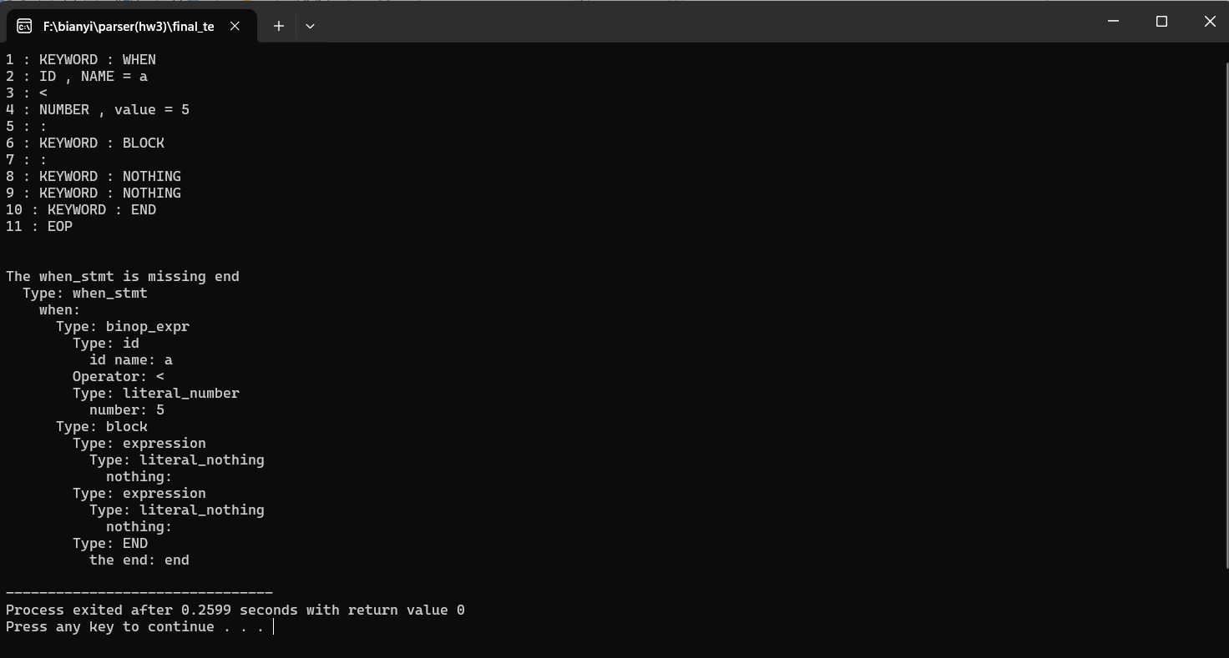

**<decl-stmt> => <var-decl> | <fun-decl>**

**<var-decl> => (shadow)? (rec)? var <id> = <expr>**

**[shadow var]**

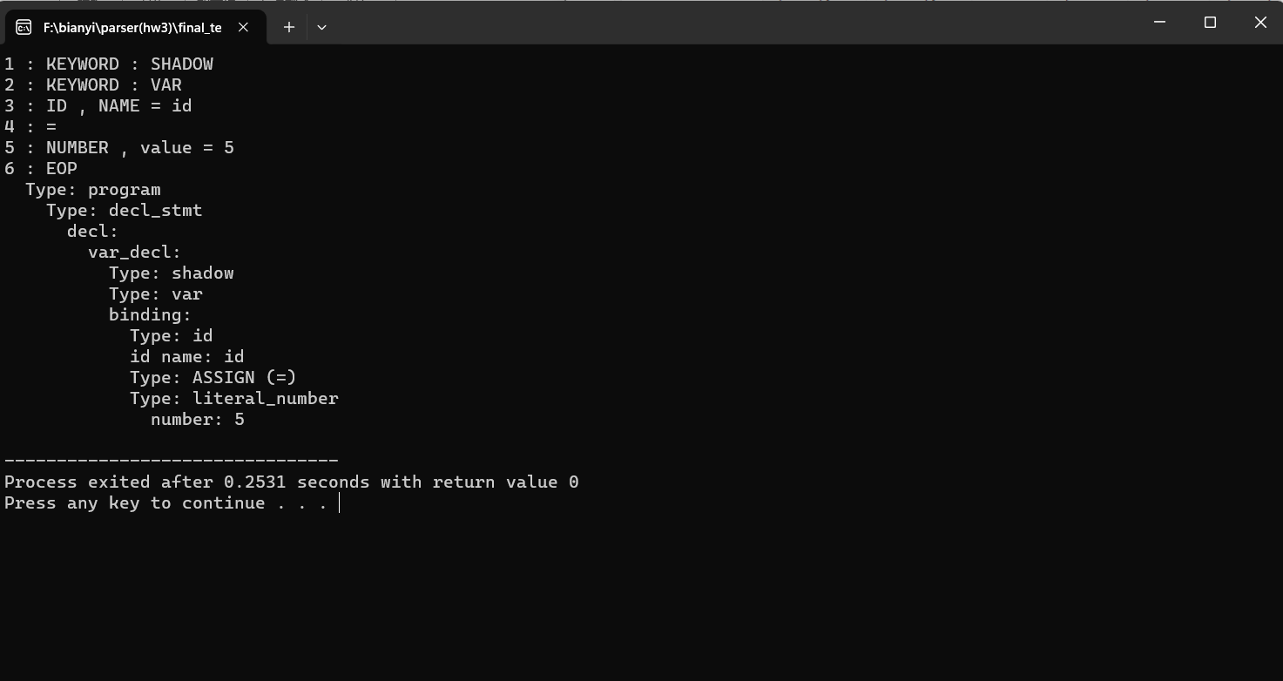

**[rec var]**

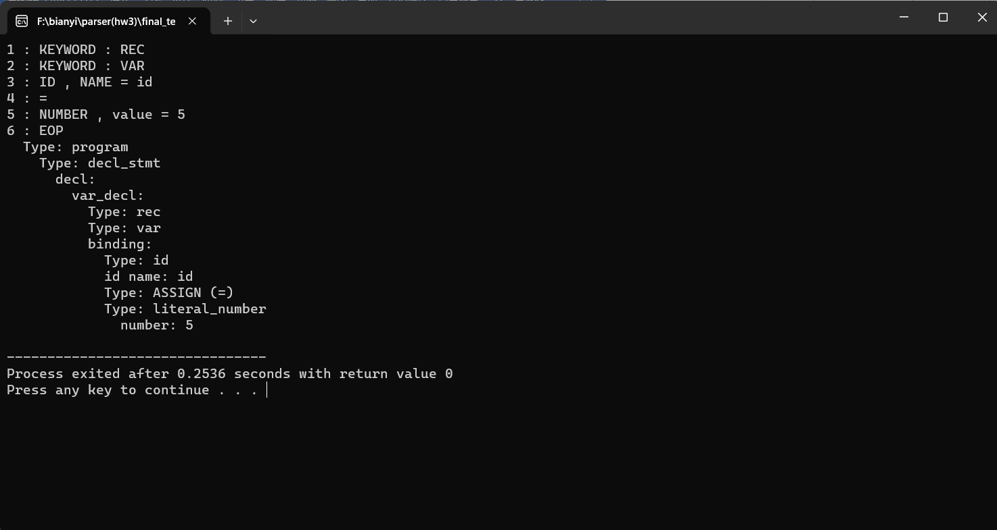

**[var]**

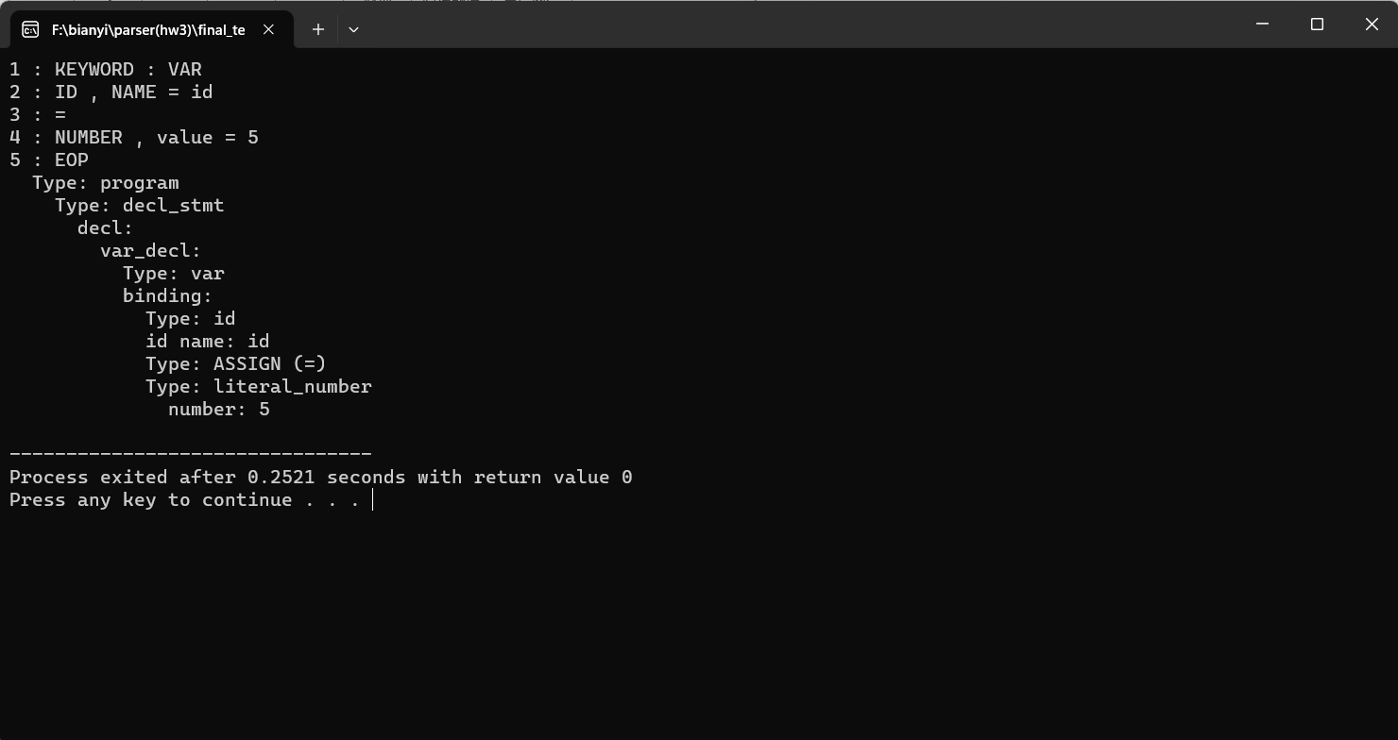

**<fun-decl> => (shadow)? (rec)? fun <id> <fun-header> : <stmts> end**

**<fun-header> => \( < params>  \) (<return-part>)**

**<return-part> =>  -> <type-name>**

**<params> => e | <param_list>**

**<param_list> => (<param> ,)* <param>**

**<param> =>  (shadow)? <id> [:: <type-name>]**

**<type-name> => Any | Number | String | Boolean | Nothing | Function**

**[shadow fun]**

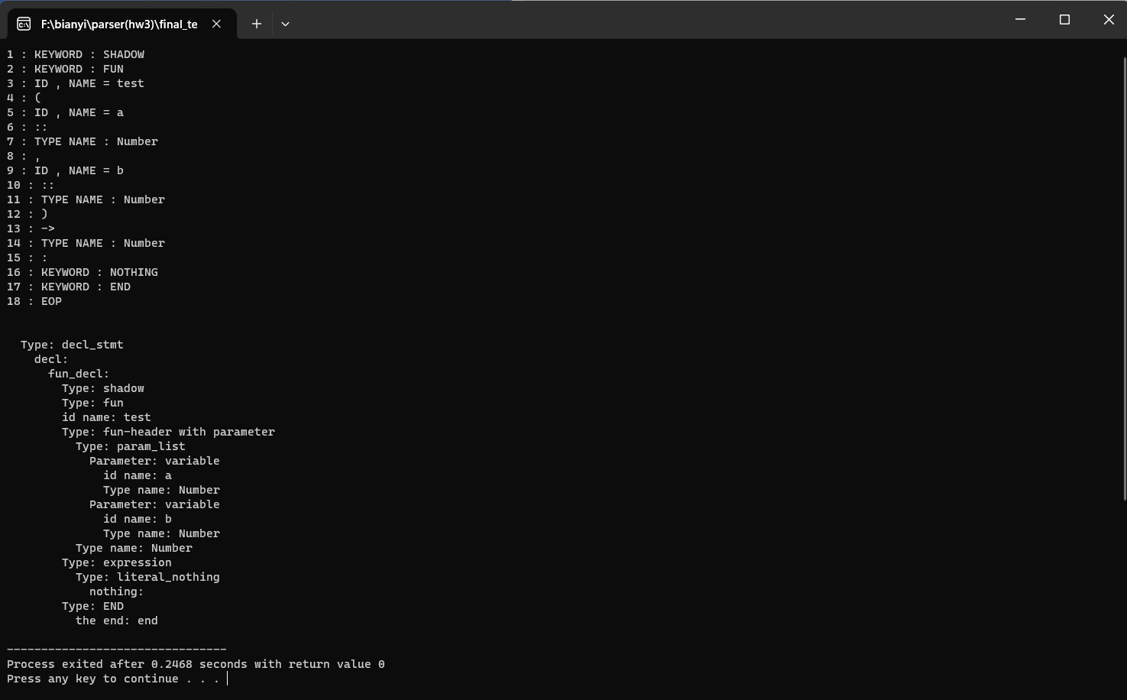

**[rec fun]**

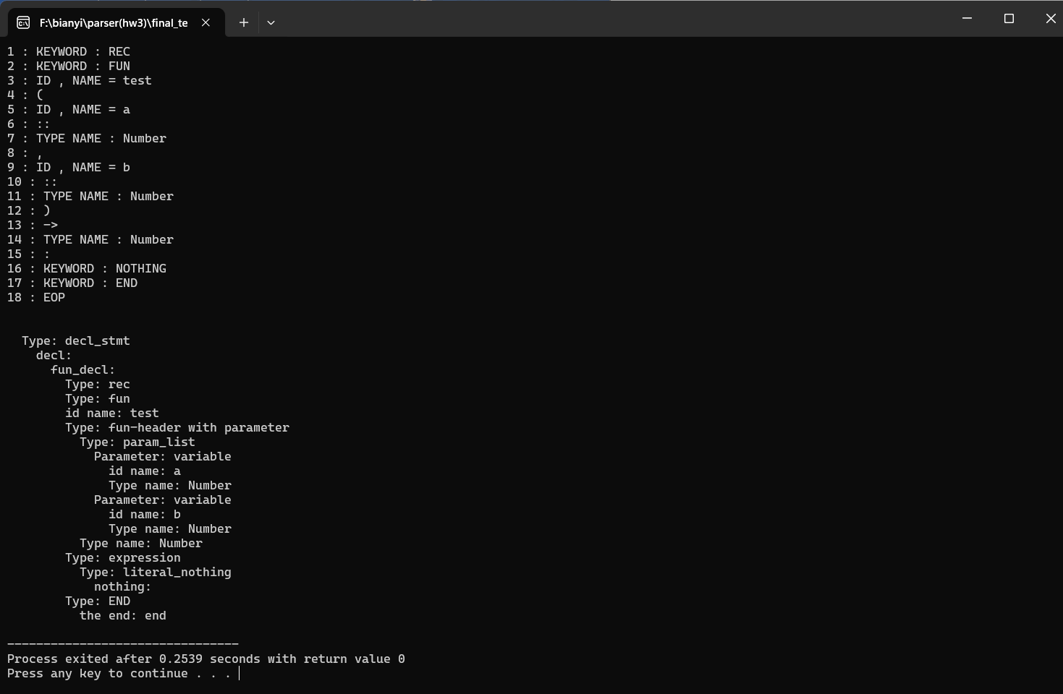

**[fun]**

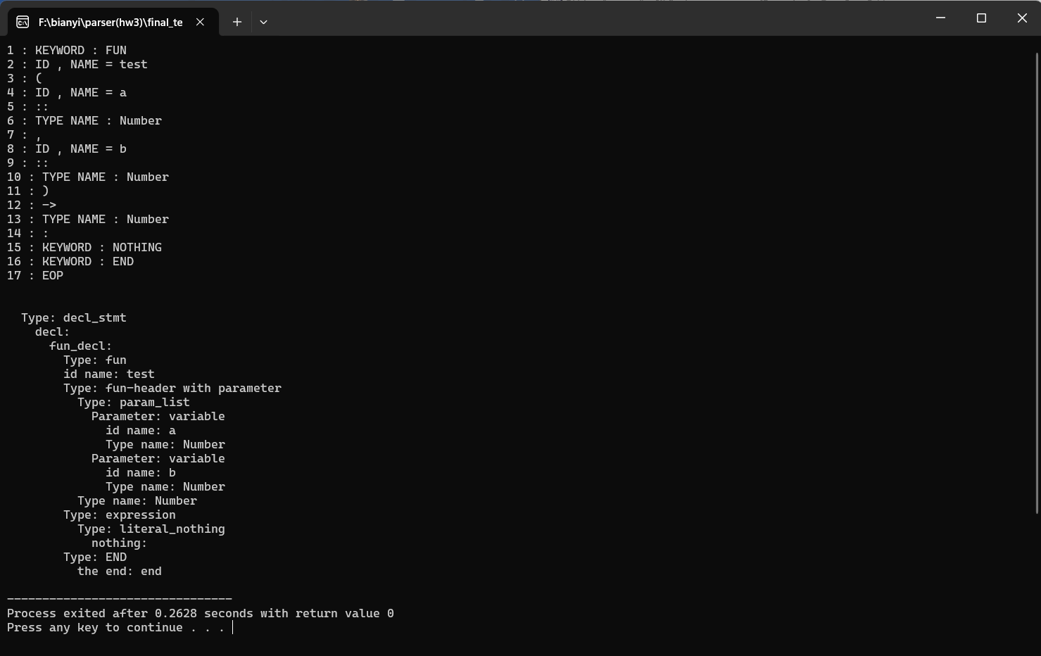

**Test results with complex correct Pyr code:**

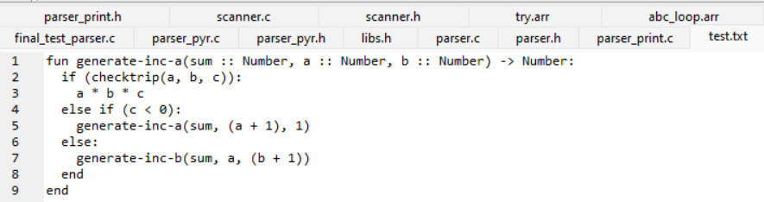

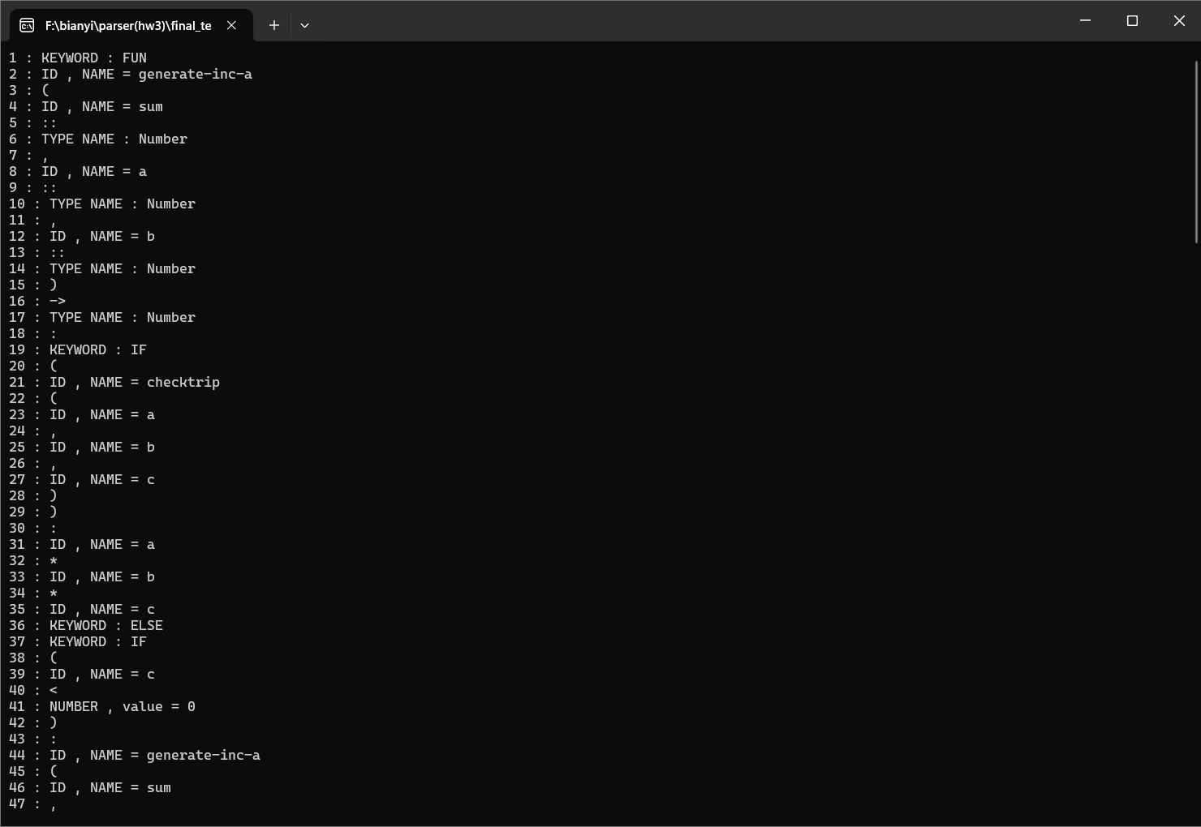

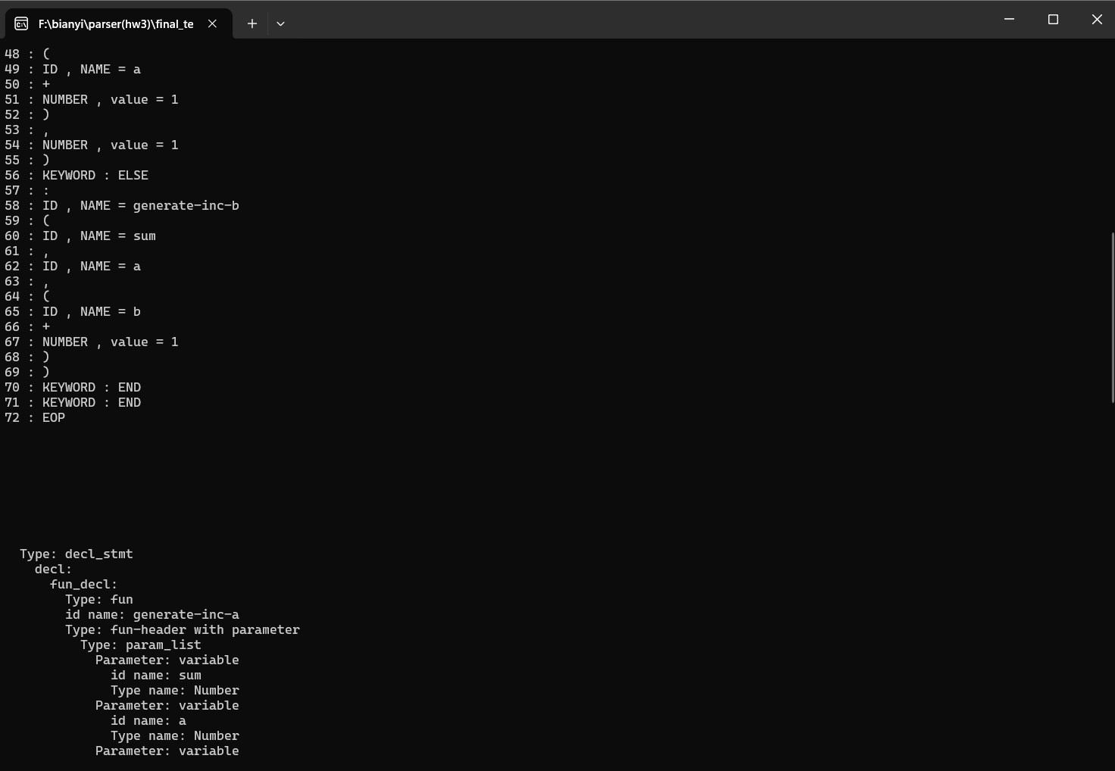

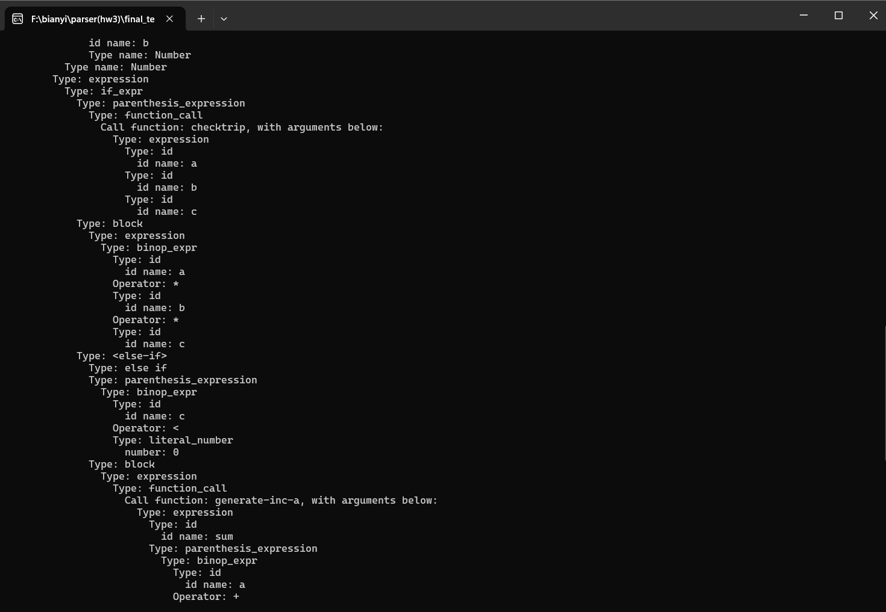

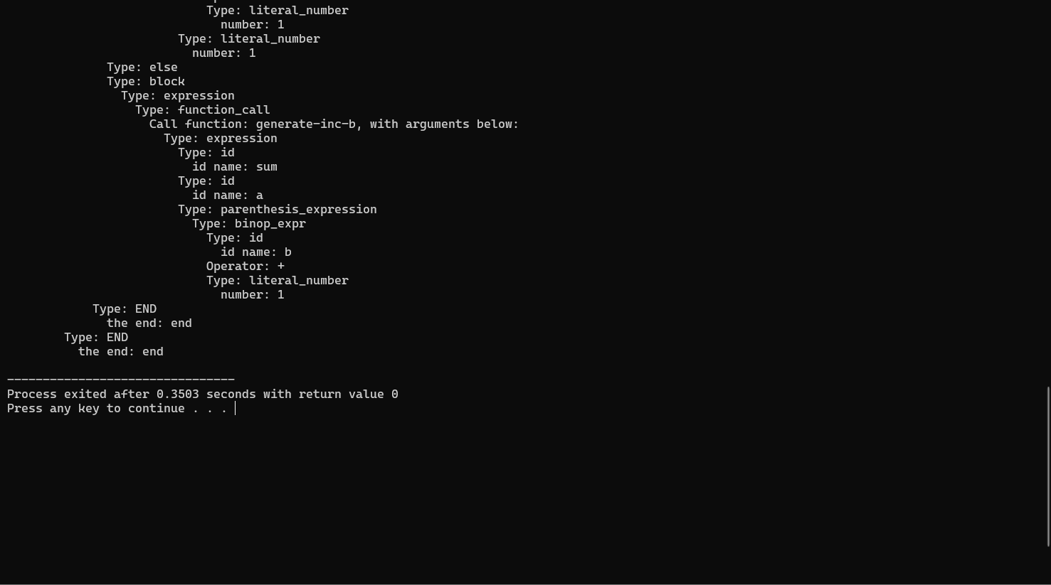

**Test results with syntex errors:**

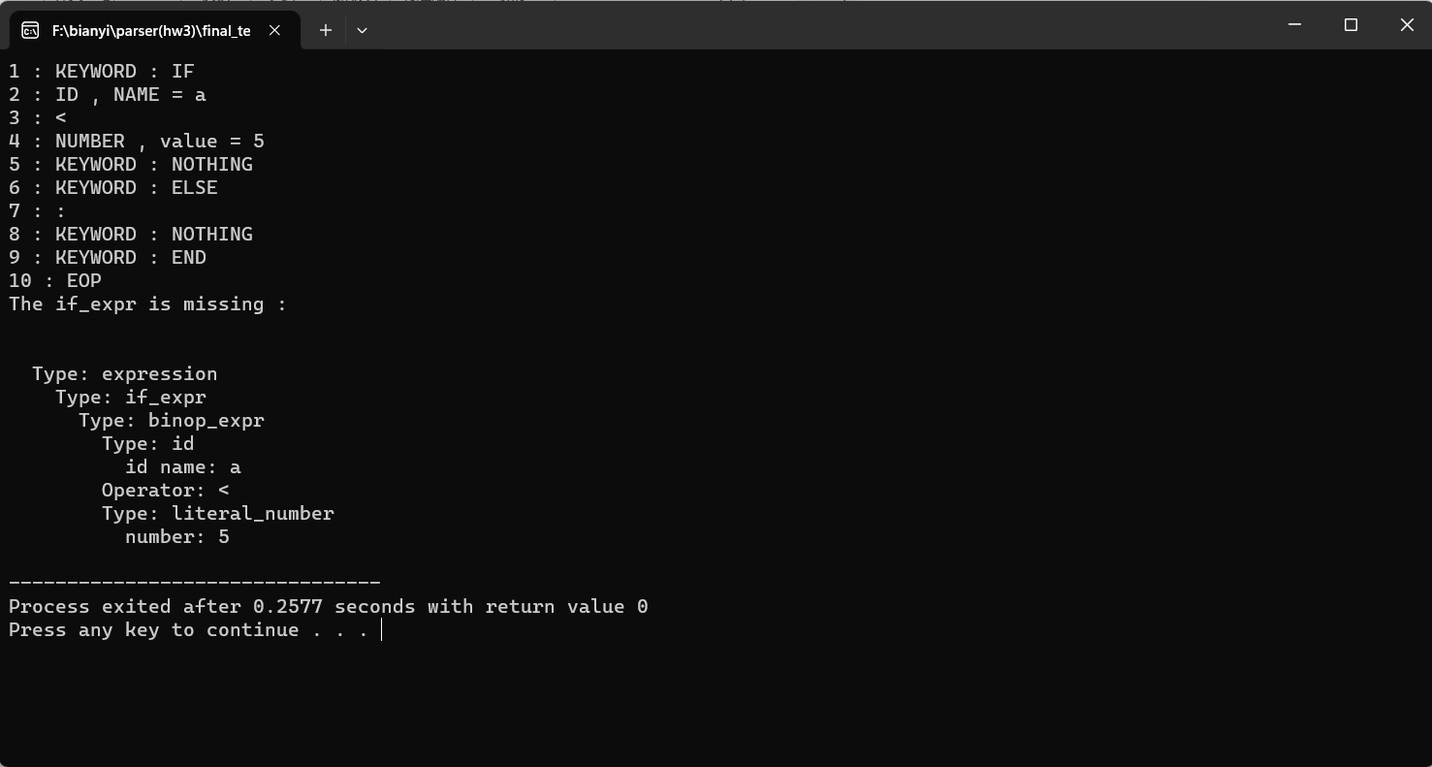

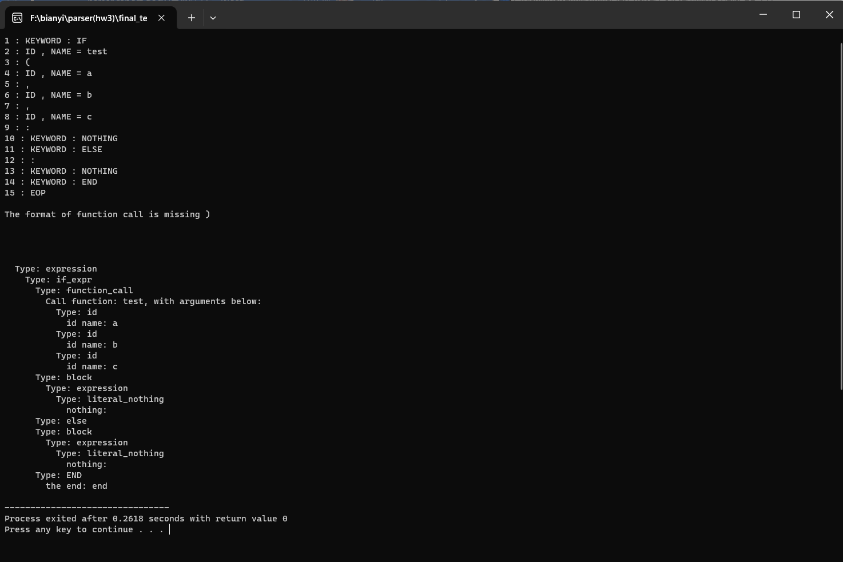

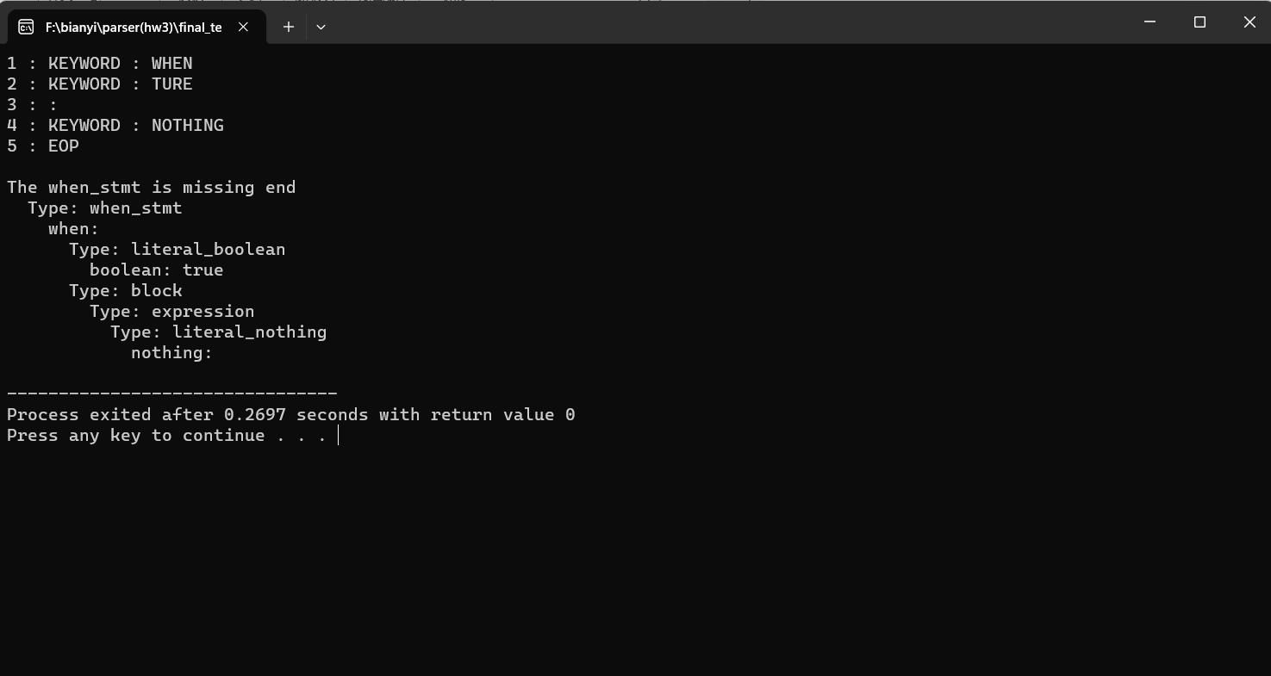

* **Descriptions(run and complie) :**

**The way I use to find where is the error that cause problems:**

**During compling, sometimes I can’t get the expected parser tree from the list according to the grammar, so I use the printf(“%s”,”parser); to locate where the error occurred like the way shown in below:**

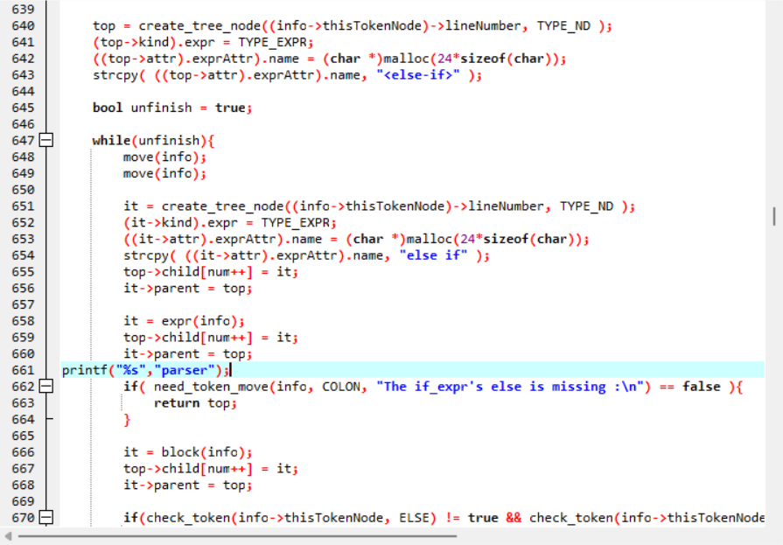

**and then use the text.txt file to print out the result.**

**If there is parser shown, the means the part above the printf sentence is ok; otherwise, it means something is wrong with the above codes.**

**With several checks around the codes that seems to have problems, this method helped me the narrow down to where the error was.**

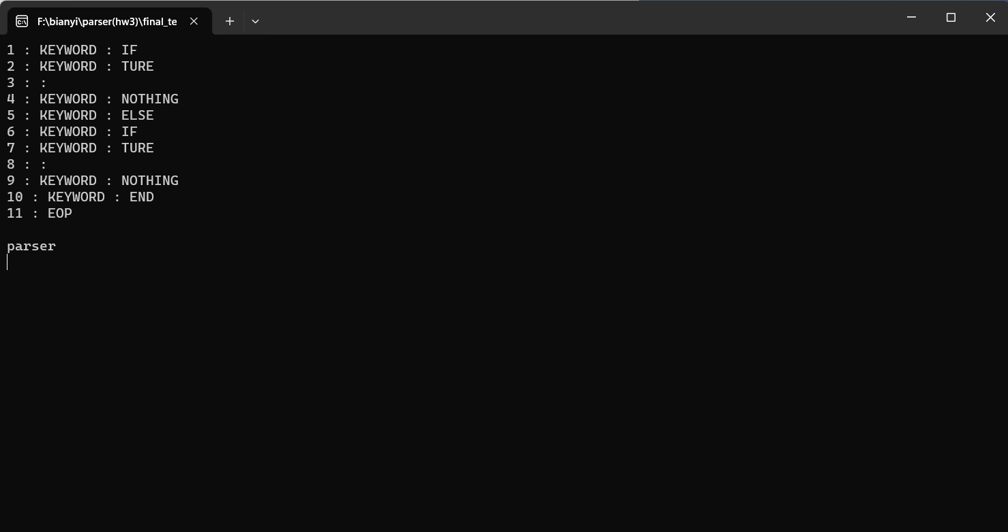

**The changes I make according to the provides helpful code:**

**[parser.h]**

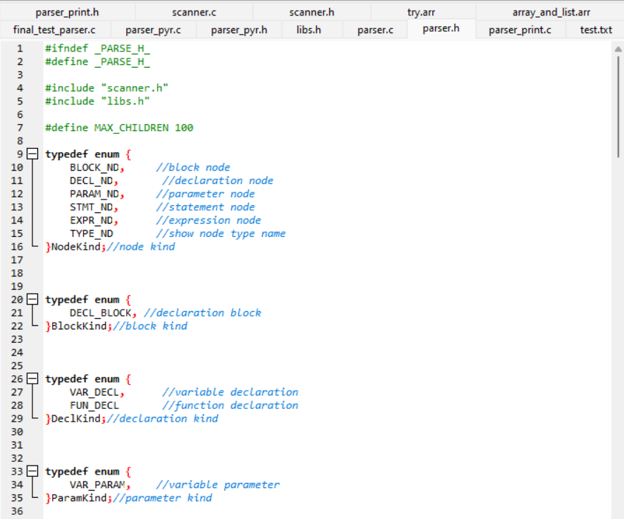

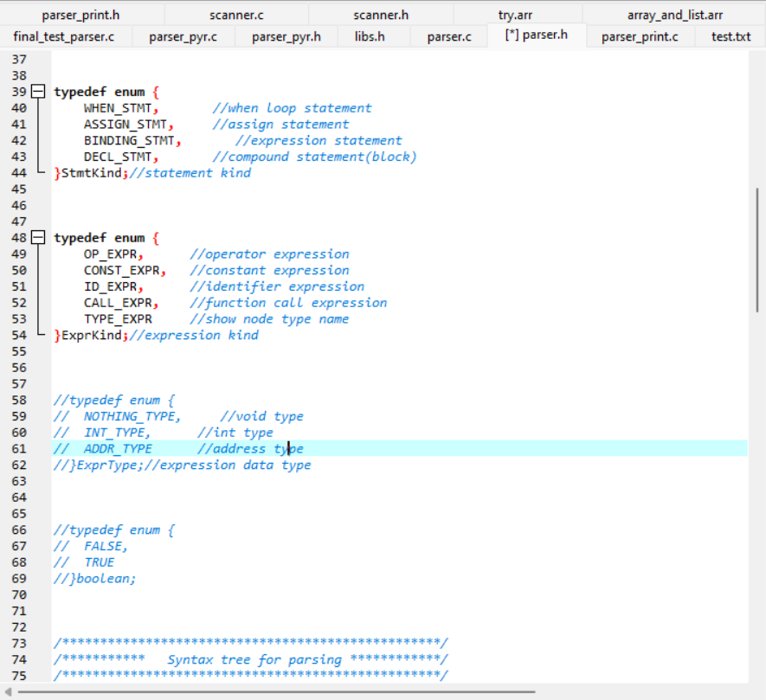

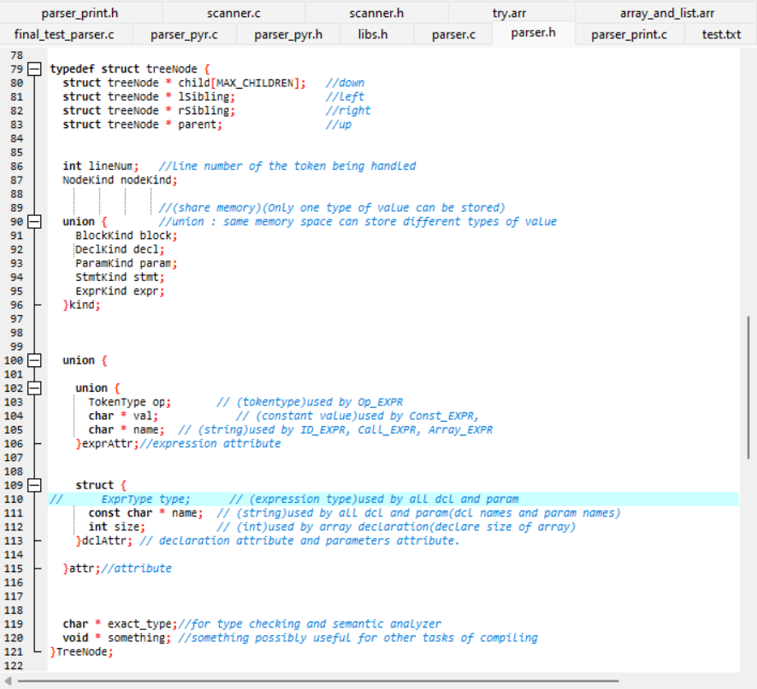

I add an char * exact_type; to show the details information of the current node

**[parser_print.c]**

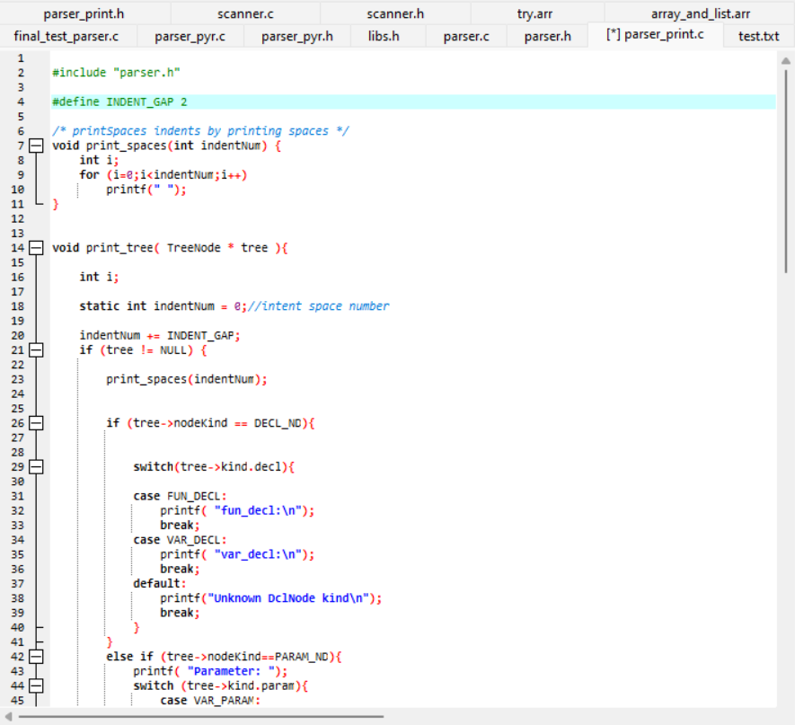

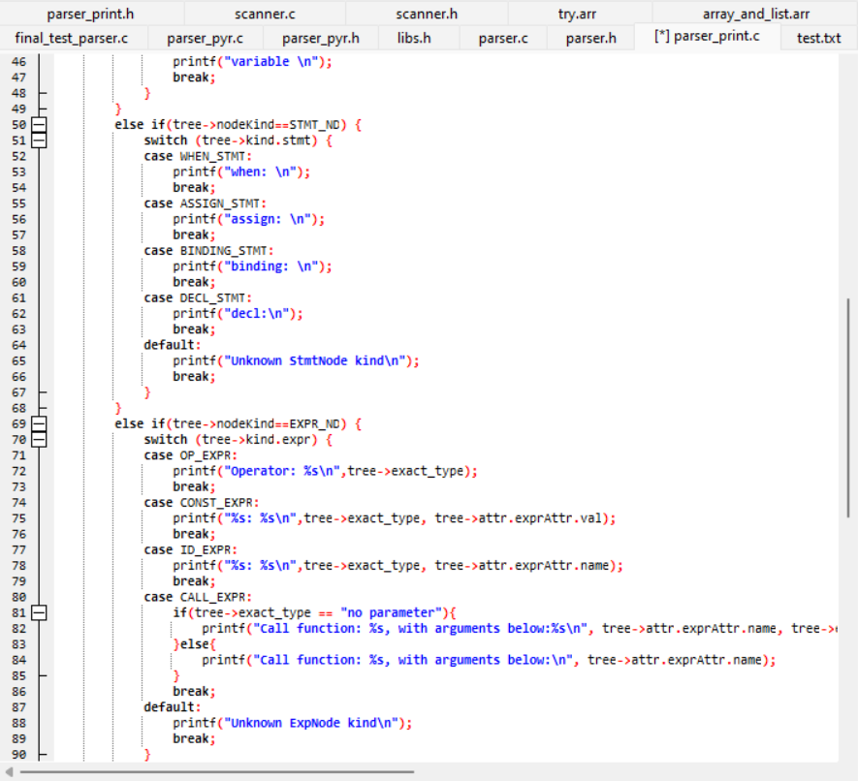

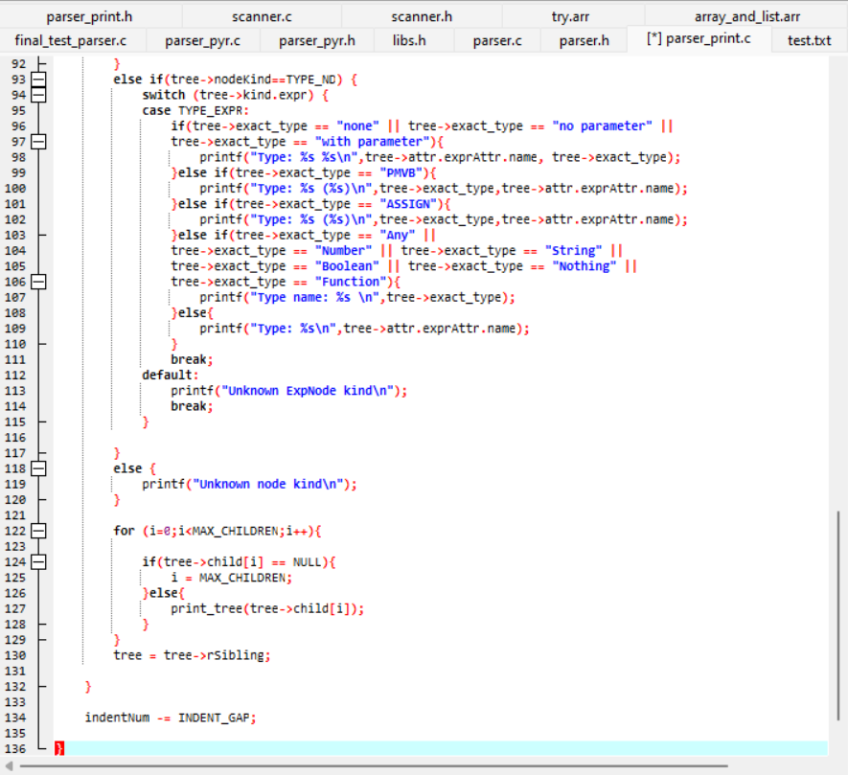

**The file I used to test the result:**

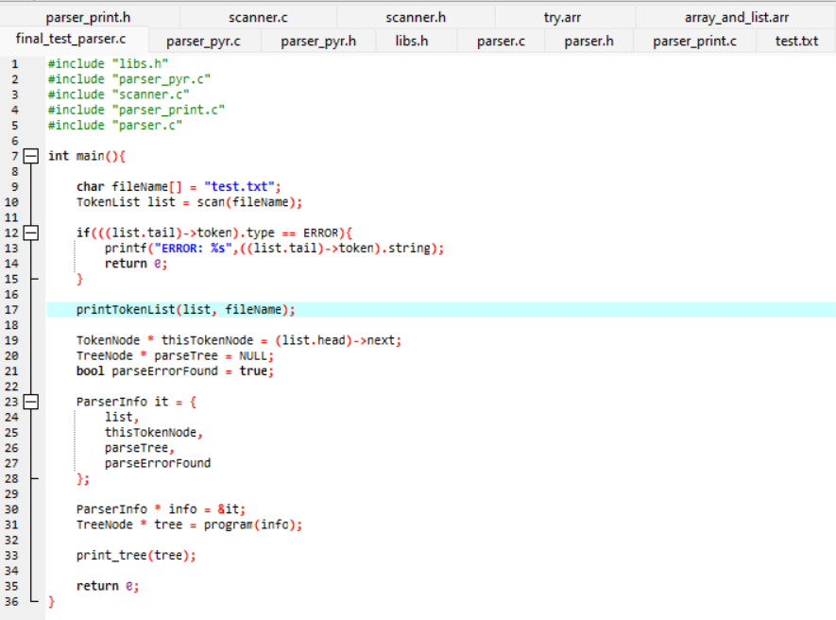

* **Problems :**

**According to the limited of time and my code ability, the above contents are all I have done. However, I still have many problems to be solved.**

1. **A parse tree can be produced from only one piece of code**

**Here is a test to show the problem**

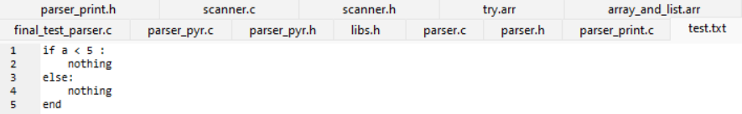

**When there is only one piece of code in the program, the parser tree can be produced.**

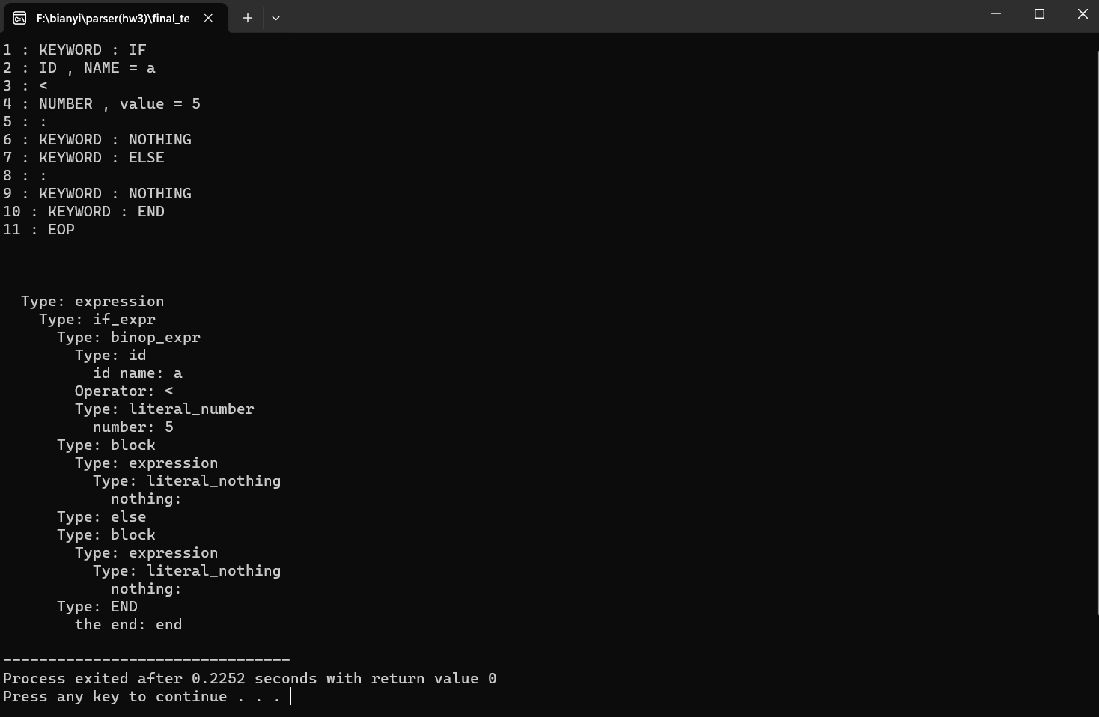

**However, when there are two pieces of code, only one parser tree can be generated.**

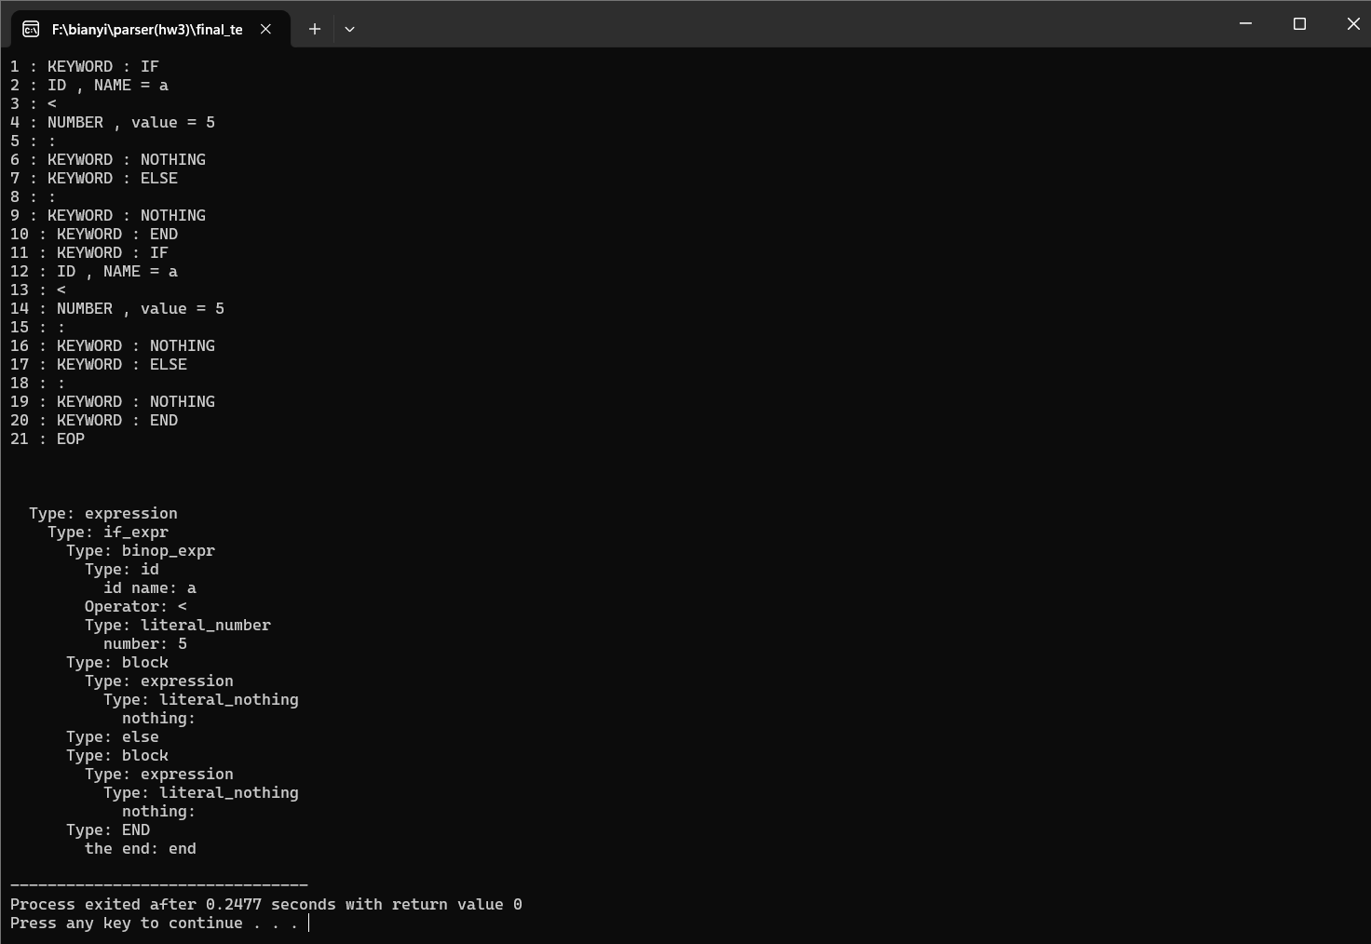

1. **I am not sure the way to deal with these grammars :**

<expr> =>  <non-op-expr>  | <op-expr>

<non-op-expr> => <id> | <literal> | <fun-call> |

                   \( <expr> \) | <if-expr> | <block> |

                   <construct-expr> | <lambda-expr>

<op-expr> => <binop-expr> | <unop-expr>

<unop-expr> => <unop> ( <non-op-expr> |  <paren-expr> )

<unop> => not

<binop-expr> => <non-op-expr> <binop> ( <non-op-expr> | <paren-expr> )

<binop> => [+ , - , * , / , < , <= , > , >= ,  == ]

**I wrote a containsOP() function to check whether the coming list contains operator or not, and use it to distinguish the** <binop-expr> **and** <non-op-expr>

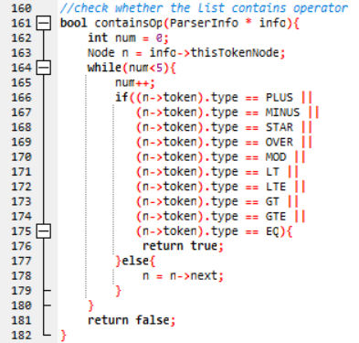

**And here is the expr() function**

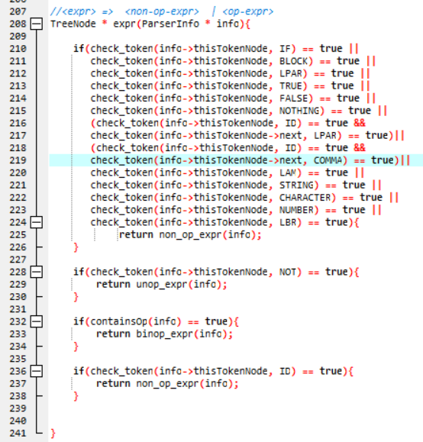

**I know that the way I used will cause many problems if the number of tests are big enough but it’s the only way I can figure it out by myself. Hope to get more information about the solution in the future.**

1. **The parser is not perfect enough.**

**There are many grammars that I haven’t got time to finish and some problems that exists but I haven’t found it. There are still a lot of work to do in the future.**